Python Assessment

Guidlines:

*Use each question as an opportunity to showcase your python skills. Describe in the way you think can best explain the question and concept behind it. Use diagram or code snippet examples wherever possible. Don’t spend more than 45 to 60 minutes on below 15 questions.*

1. Explain in brief, difference between Django, Pyramid and Flask

**Answer:**

* Flask is a "microframework" primarily aimed at small applications. Pyramid and Django are both aimed at larger applications.Pyramid and Flask targets flexibility and let us decide to use the right tools for their project in case Django comes with built in tools.
* Django has for templating, forms, routing, authentication, basic database administration, and more built in. In contrast, Pyramid, Flask includes routing and authentication, but templating and database administration require external libraries.
* Django has active community in stack overflow then Pyramid and Flask. In case of GitHub they have similar reach.
* Django and Pyramid both come with bootstrapping tools built in.
* Pyramid is the most flexible of the three. It can be used for small apps as big apps too like DropBox. the most popular framework is Django like Bitbucket, Pinterest, Instagram.Flask is great for developers working on small projects that need a fast way to make a simple, Python-powered web site.

1. If a list is nums=[0,1,2,3,4], what is nums[-1]?

**Answer:** 4

1. Explain the output of the following piece of code-

>>> tuple=(123,'John')

>>> tuple*=2

>>> tuple

**Answer:** It is a tuple defined and immutable so the output will be repeated 2 times of the defined tuple (123,'John',123,’John’)

1. Differentiate between the append() and extend() methods of a list with an example.

**Answer:** append adds its argument as a single element to the end of a list. The length of the list itself will increase by one.

Extend iterates over its argument adding each element to the list, extending the list. The length of the list will increase by however many elements were in the iterable argument.

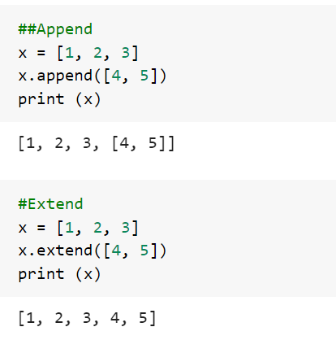

1. How do you remove the leading whitespace in a string? For example, leading whitespace in a string is the whitespace in a string before the first non-whitespace character. Eg. ' Maersk'

**Answer:** ' Maersk'.strip()

1. What is the enumerate () function in Python? Explain with an example.

**Answer:** Is a built-in function takes the given input as a collection and returns it as an enumerate object.  Enumerate function comes with an automatic index to each of the items present in the Enumerate list in Python. The firstindex value will start from 0.

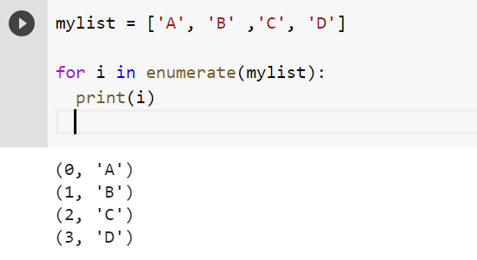

1. Explain at least three advantages of NumPy Array over the list in python.

**Answer:**

1. **Memory** - Numpy data structures take up less space.
2. **Speed** - they have a need for speed and are faster than lists
3. **Functionality** - SciPy and NumPy have optimized functions such as linear algebra operations built in, FFTs, convolutions, fast searching, basic statistics,

1. List out all the possible differences between method and constructor in Python.

**Answer:** Constructor is a block of code that initializes a newly created object, and A Method is a collection of statements which returns a value upon its execution.

Constructors create and initialize objects that don't exist yet, while methods perform operations on objects that already exist.

Constructors can't be called directly; they are called implicitly when the new keyword creates an object. Methods can be called directly on an object that has already been created with new.

The definitions of constructors and methods look similar in code. They can take parameters, they can have modifiers (e.g., public), and they have method bodies in braces.

Constructors must be named with the same name as the class name. They can't return anything, even void (the object itself is the implicit return). Methods must be declared to return something, although it can be void.

A Constructor is invoked implicitly by the system whereas A Method is invoked through method calls.

1. Define generator and iterator with an example in Python. What is Monkey Patching?

**Answer:** Iterators are used mostly to iterate or convert other objects to an iterator using iter() function. It follows lazy evaluation where the evaluation of the expression will be on hold and stored in the memory until the item is called specifically which helps us to avoid repeated evaluation. iter() keyword is used to create an iterator containing an iterable object. next() keyword is used to call the next element in the iterable object.

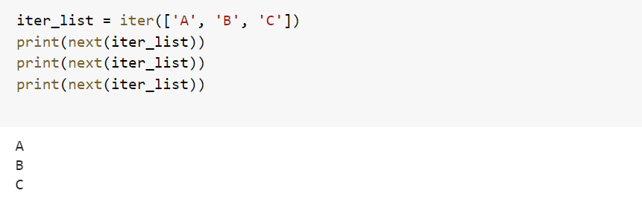

Generators are mostly used in loops to generate an iterator by returning all the values in the loop without affecting the iteration of the loop. Generator uses yield keyword. generators also follow lazy evaluation. Here, the yield function returns the data without affecting or exiting the function.Question Number 10 is an example

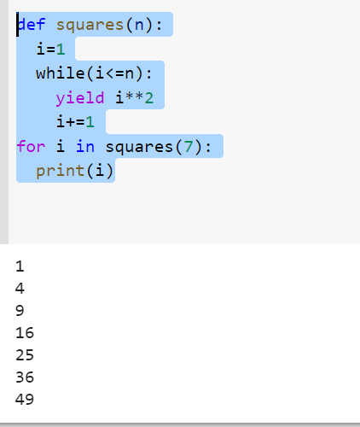

Monkey Patching is making changes to a module or class while the program is running (Dynamic Modification)

The most common usecase is adding a workaround for a bug in a module or class when you can't replace the original code. In this case you replace the "wrong" code through monkey patching with an implementation inside your own module/package.

1. What will the output of the following code snippet:

>>> def squares(n):

i=1

while(i<=n):

yield i**2

i+=1

>>> for i in squares(7):

print(i)

**Answer :**

1

4

9

16

25

36

49

**Embedded Theory Questions**

1. How I/O devices are classified for embedded system?

**Answer:** I/O devices are classified as either character-mode devices or block-mode devices. The classification refers to how the device handles data transfer with the system.

Character-mode devices allow for unstructured data transfers. The data transfers typically take place in serial fashion, one byte at a time. Character-mode devices are usually simple devices, such as the serial interface or the keypad. The driver buffers the data in cases where the transfer rate from system to the device is faster than what the device can handle.

Block-mode devices transfer data one block at time, for example, 1,024 bytes per data transfer. The underlying hardware imposes the block size. Some structure must be imposed on the data or some transfer protocol enforced. Otherwise an error is likely to occur. Therefore, sometimes it is necessary for the block-mode device driver to perform additional work for each read or write operation.

1. What is the difference between Microprocessor and Microcontroller?

**Answer:**

* Microprocessor consists of only a Central Processing Unit, whereas Micro Controller contains a CPU, Memory, I/O all integrated into one chip.
* Microprocessor is used in Personal Computers whereas Micro Controller is used in an embedded system.
* Microprocessor uses an external bus to interface to RAM, ROM, and other peripherals, on the other hand, Microcontroller uses an internal controlling bus.
* Microprocessors are based on Von Neumann model Micro controllers are based on Harvard architecture
* Microprocessor is complicated and expensive, with a large number of instructions to process but Microcontroller is inexpensive and straightforward with fewer instructions to process.

1. What is a Watchdog Timer?

**Answer:** A watchdog timer is a (electronic device) simple countdown timer which is used to reset a microprocessor after a specific interval of time. In a properly operating system, software will periodically "pet" or restart the watchdog timer. After being restarted, the watchdog will begin timing another predetermined interval.

1. What are common errors in Embedded system?

**Answer:**

* Damage of memory devices static discharges and transient current.
* Address line malfunctioning due to a short in circuit.
* Data lines malfunctioning.
* Due to garbage or errors some memory locations being inaccessible in storage.
* Wrong control signals

1. What is the need for an infinite loop sometimes in embedded systems?

**Answer:**  Infinite loops are used to keep the embedded system functional. If infinite loop is not used, after executing the task once, the embedded system will come to hault which is not the desired condition

**Assessment for Machine Learning**

*Generic guidelines*

*Should be written in Python or C.*

*Use Object Oriented Programming approach to solve the problem.*

*Use DRY (Don’t Repeat Yourself) Principle and Clean code practices.*

*Commit your code to your Git repo.*

*Commits should be incremental with adequate and descriptive comments.*

*Don’t spend more than 1.5 hours to 2 hours of time on coding assessments.*

**Problem Statement 1**

*Define a ML technique that you would use for the fake news detection.*

*Build a Machine learning Model to detect the Fake new detection.*

*We could use online Jupyter Lab or similar environment to build, train and test the model*

*You could use your choice of dataset for the training and testing this model or any*

*dataset from* [*https://www.kaggle.com/datasets?search=Fake+news*](https://www.kaggle.com/datasets?search=Fake+news)

*Based on the Test data set you should also be able to identify the accuracy of the Model*

*GitHub Link :* [*https://github.com/sankalppatnaik/Maersk*](https://github.com/sankalppatnaik/Maersk)

Fake news Detection.zip

**Problem Statement 2**

*Create an Image Analytics script to detect License Number plate in the images.*

*You could use OpenCV or Libraries of your choice. The application should draw a bounding box around the License plate and blur the license plate.*

*We could use online Jupyter Lab or similar environment to build this.*

*Hint: you could use OpenCV cascade Classifier for this exercise*

*https://github.com/opencv/opencv/blob/master/data/haarcascades/haarcascade_russian_plate_number.xml*

*GitHub Link :* [*https://github.com/sankalppatnaik/Maersk*](https://github.com/sankalppatnaik/Maersk)

Detect License Number Plate.zip